**1. To convert temperature in Celsius to Fahrenheit and vice versa**

print("Convert Celsius to Farenheit and vice versa")

i=1

while i<=3:

choice=input("Enter your Choice:")

if choice=='1':

c=int(input("Enter the Temperature in Celcius:"))

f = (9/5)*c + 32

print("Temperature in Farenheit is:",f)

elif choice=='2':

f=int(input("Enter the Temperature in Farenheit:"))

c = (5/9)*(f - 32)

print("Temperature in Farenheit is:",c)

elif choice=='3':

break

i=i+1

**OUTPUT:**

Convert Celsius to Farenheit and vice versa

Enter your Choice:1

Enter the Temperature in Celcius:38

Temperature in Farenheit is: 100.4

Enter your Choice:2

Enter the Temperature in Farenheit:100

Temperature in Farenheit is: 37.77777777777778

Enter your Choice:3

**2. To Calculate Total marks, Percentage and Grade of a Student**

print("Program to calculate Grade of a Student ")

n = int(input("Enter how many Subjects: "))

print("Enter the marks for 5 subjects:")

sum=0.0

for i in range(n):

x=int(input())

mark[i]=x

sum=sum+mark[i]

print("Total Marks",sum)

percentage = (sum/500)*100;

print("Percentage",percentage)

if(percentage >=80 and percentage <=100):

print("Your Grade is A")

elif(percentage >=70 and percentage <80):

print("Your Grade is B")

elif(percentage >=60 and percentage<70):

print("Your Grade is C")

elif(percentage >=40 and percentage<60):

print("Your Grade is D")

else:

print("Your Grade is E")

**OUTPUT:**

Program to calculate Grade of a Student

Enter how many Subjects: 5

Enter the marks for 5 subjects:

90

90

90

90

90

Total Marks 450.0

Percentage 90.0

Your Grade is A

**3. Program to find the Area of Rectangle, Square, Circle and**

**Triangle**

print("Program to find the area of rectangle, square, circle and triangle ")

print("-----------------------------------------------------------------------------")

i=1

while i<=4:

print("1: Area of a Rectangle\n2: Area of a Square\n3: Area of a Circle \n4: Area of a Triangle ")

option = int(input("Enter your choice: "))

if option==1:

print("AREA OF RECTANGLE")

print("-----------------")

length = int(input("Enter length of Rectangle: "))

breadth = int(input("Enter breadth of Rectangle:"))

area = length*breadth

print("\nArea of Rectangle =",area)

elif option==2:

print("AREA OF SQUARE")

print("--------------")

side = int(input("Enter side length of Square:"))

area_square = side*side

print("\nArea of Square =",area_square)

elif option==3:

print("AREA OF CIRCLE")

print("--------------")

radius = float(input("Enter radius of circle: "))

area = 3.14*radius*radius;

print("\nArea of Circle = ", area)

elif option==4:

print("AREA OF TRIANGLE")

print("----------------")

breadth = float(input("Enter Breadth of Triangle: "))

height = float(input("Enter Height of Triangle: "))

area = (breadth*height)/2

print("\nArea of Triangle = ", area)

else:

print("Invalid Option")

break

i=i+1

**OUTPUT:**

Program to find the area of rectangle, square, circle and triangle

---------------------------------------------------------------------------

1: Area of a Rectangle

2: Area of a Square

3: Area of a Circle

4: Area of a Triangle

Enter your choice: 1

AREA OF RECTANGLE

-----------------

Enter length of Rectangle: 3

Enter breadth of Rectangle:4

Area of Rectangle = 12

1: Area of a Rectangle

2: Area of a Square

3: Area of a Circle

4: Area of a Triangle

Enter your choice: 2

AREA OF SQUARE

--------------

Enter side length of Square:4

Area of Square = 16

1: Area of a Rectangle

2: Area of a Square

3: Area of a Circle

4: Area of a Triangle

Enter your choice: 3

AREA OF CIRCLE

--------------

Enter radius of circle: 3.5

Area of Circle = 38.465

1: Area of a Rectangle

2: Area of a Square

3: Area of a Circle

4: Area of a Triangle

Enter your choice: 4

AREA OF TRIANGLE

----------------

Enter Breadth of Triangle: 5

Enter Height of Triangle: 6

Area of Triangle = 15.0

1: Area of a Rectangle

2: Area of a Square

3: Area of a Circle

4: Area of a Triangle

Enter your choice: 5

Invalid Option

**4. Fibonacci Series**

print("Fibonacci Series")

print("-----------------")

num = int(input("Enter number of terms you want in the series (minimum 2): "))

first = 0

second = 1

print("\nFibonacci Series is:")

print(first, ",", second, end=", ")

for i in range(2, num):

next = first + second

print(next, end=", ")

first = second

second = next

**OUTPUT :**

Fibonacci Series

--------------------

Enter number of terms you want in the series (minimum 2): 10

Fibonacci Series is : 0 , 1, 1, 2, 3, 5, 8, 13, 21, 34,

**5. FACTORIAL OF GIVEN NUMBER**

print("FACTORIAL OF GIVEN NUMBER :")

print("------------------------- :")

def factorial(n):

if(n <= 1):

return 1

else:

return(n*factorial(n-1))

n = int(input("Enter number:"))

print("The factorial of",n,"is",factorial(n))

**OUTPUT:**

FACTORIAL OF GIVEN NUMBER:

--------------------------------------------- :

Enter number: 7

The factorial of 7 is 5040

**6. To Count Even and Odd Numbers in a List**

# Python Program to Count Even and Odd Numbers in a List

NumList = []

Even_count = 0

Odd_count = 0

print("To count the number of even and odd numbers from array of N numbers")

print("-------------------------------------------------------------------")

Number = int(input("Please enter the Total Number of List Elements: "))

for i in range(1, Number + 1):

value = int(input("Please enter the Value of %d Element : " %i))

NumList.append(value)

for j in range(Number):

if(NumList[j] % 2 == 0):

Even_count = Even_count + 1

else:

Odd_count = Odd_count + 1

print("\nTotal Number of Even Numbers in this List = ", Even_count)

print("Total Number of Odd Numbers in this List = ", Odd_count)

**OUTPUT:**

To count the number of even and odd numbers from array of N numbers

---------------------------------------------------------------------------------------

Please enter the Total Number of List Elements: 10

Please enter the Value of 1 Element : 1

Please enter the Value of 2 Element : 3

Please enter the Value of 3 Element : 5

Please enter the Value of 4 Element : 7

Please enter the Value of 5 Element : 2

Please enter the Value of 6 Element : 4

Please enter the Value of 7 Element : 6

Please enter the Value of 8 Element : 8

Please enter the Value of 9 Element : 10

Please enter the Value of 10 Element : 12

Total Number of Even Numbers in this List = 6

Total Number of Odd Numbers in this List = 4

**7. Calculate the number of upper case letters and lower case letters**

def countUpperLower(sentence):

upper = 0

lower = 0

for i in sentence:

if i >='A' and i <= 'Z':

upper += 1

elif i >= 'a' and i <= 'z':

lower += 1

print("Calculate the Number of Upper Case Letters and Lower Case Letters")

print("-----------------------------------------------------------------")

print("Input String: ",sentence)

print("Upper case: " + str(upper))

print("Lower case: " + str(lower))

countUpperLower("Welcome To Python World")

**OUTPUT:**

Calculate the Number of Upper Case Letters and Lower Case Letters

-----------------------------------------------------------------------------------

Input String: Welcome To Python World

Upper case: 4

Lower case: 16

**8. To Check a Given String is Palindrome or Not**

# Python Program to Check a Given String is Palindrome or Not

print("To Check a Given String is Palindrome or Not")

print("--------------------------------------------")

string = input("Enter the String : ")

# make it suitable for caseless comparison

string = string.casefold()

rev_str = reversed(string)

if list(string) == list(rev_str):

print("The given string is a palindrome.")

else:

print("The given string is not a palindrome.")

**OUTPUT:**

To Check a Given String is Palindrome or Not

-------------------------------------------------------

Enter the String : Liril

The given string is a palindrome.

To Check a Given String is Palindrome or Not

-------------------------------------------------------

Enter the String : Tagore

The given string is not a palindrome.

**9. To find Sum of Items in a Dictionary**

# Python Program to find Sum of Items in a Dictionary

print("Program to find Sum of Items in a Dictionary")

print("---------------------------------------------")

myDict = {'x': 250, 'y':500, 'z':410}

print("Dictionary: ", myDict)

total = 0

# Print Values using get

for i in myDict.values():

total = total + i

print("\nThe Total Sum of Values : ", total)

**OUTPUT:**

Program to find Sum of Items in a Dictionary

-------------------------------------------------------

Dictionary: {'x': 250, 'y': 500, 'z': 410}

The Total Sum of Values : 1160

**10. Construct a pattern using nested for loops**

print("Construct a number pattern")

for i in range(1, 10):

for j in range(i):

print(i, end=' ')

print()

**OUTPUT:**

Construct a number pattern

1

2 2

3 3 3

4 4 4 4

5 5 5 5 5

6 6 6 6 6 6

7 7 7 7 7 7 7

8 8 8 8 8 8 8 8

9 9 9 9 9 9 9 9 9

**11. Read a file content and copy only the contents at odd lines into a new file.**

# open file in read mode

fn = open('bcd.txt', 'r')

# open other file in write mode

fn1 = open('nfile.txt', 'w')

# read the content of the file line by line

cont = fn.readlines()

type(cont)

for i in range(0, len(cont)):

if(i % 2 ! = 0):

fn1.write(cont[i])

else:

pass

# close the file

fn1.close()

# open file in read mode

fn1 = open('nfile.txt', 'r')

# read the content of the file

cont1 = fn1.read()

# print the content of the file

print(cont1)

# close all files

fn.close()

fn1.close()

**OUTPUT:**

**Python**

**Is**

**12. Create a Turtle graphics window with specific size**

import turtle

drawing_area=turtle.Screen()

drawing_area.setup(width=550,height=330)

**OUTPUT:**

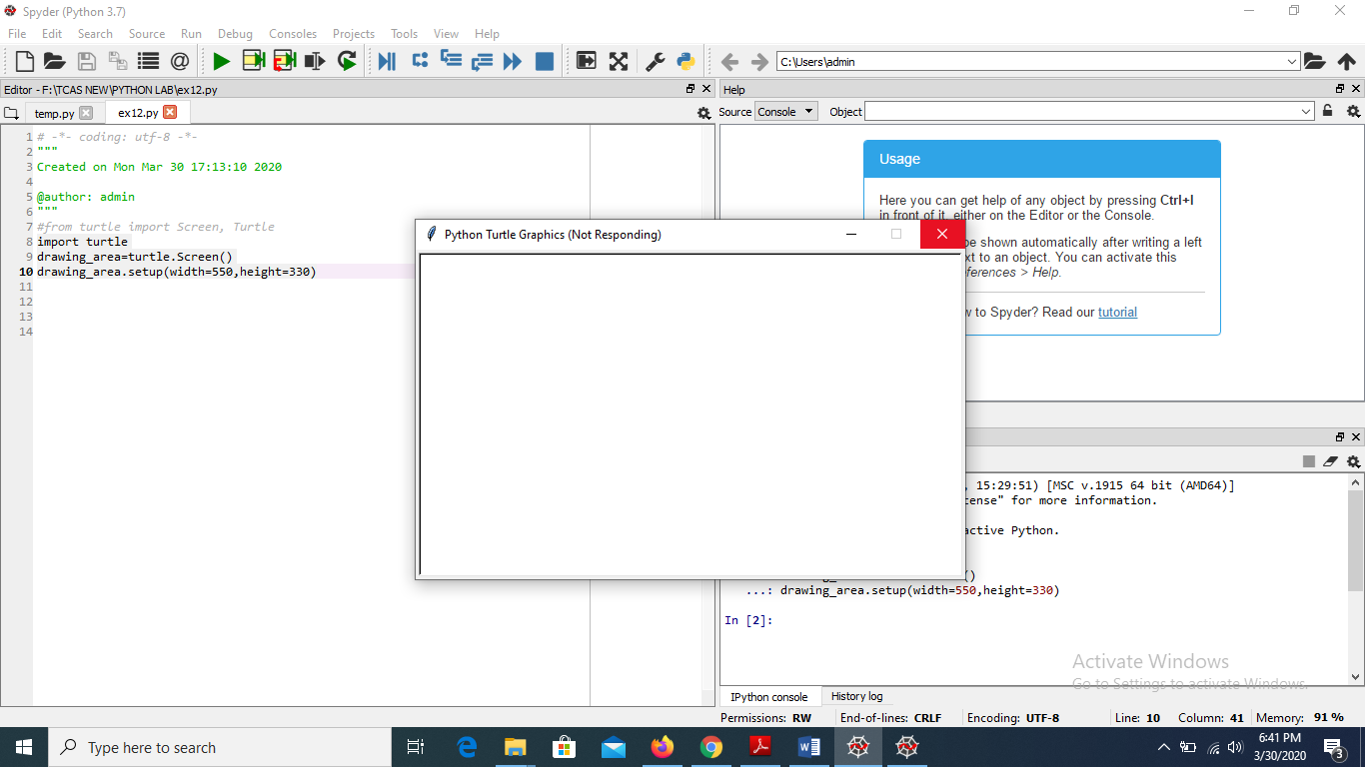

**13. Towers of Hanoi using recursion**

print("TOWER OF HANOI PROBLEM")

print("----------------------")

def hanoi(disks, source, auxiliary, target):

if disks == 1:

print('Move disk 1 from peg {} to peg {}.'.format(source, target))

return

hanoi(disks - 1, source, target, auxiliary)

print('Move disk {} from peg {} to peg {}.'.format(disks, source, target))

hanoi(disks - 1, auxiliary, source, target)

disks = int(input('Enter number of disks: '))

hanoi(disks, 'A', 'B', 'C')

**OUTPUT:**

TOWER OF HANOI PROBLEM

----------------------------------------

Enter number of disks: 3

Move disk 1 from peg A to peg C.

Move disk 2 from peg A to peg B.

Move disk 1 from peg C to peg B.

Move disk 3 from peg A to peg C.

Move disk 1 from peg B to peg A.

Move disk 2 from peg B to peg C.

Move disk 1 from peg A to peg C.

**15. To implement the Hangman Game**

import random

# library that we use in order to choose

# on random words from a list of words

name = input("What is your name? ")

# Here the user is asked to enter the name first

print("Good Luck ! ", name)

words = ['rainbow', 'computer', 'science', 'programming',

'python', 'mathematics', 'player', 'condition',

'reverse', 'water', 'board', 'geeks']

# Function will choose one random

# word from this list of words

word = random.choice(words)

print("Guess the characters")

guesses = ''

# any number of turns can be used here

turns = 12

while turns > 0:

# counts the number of times a user fails

failed = 0

# all characters from the input

# word taking one at a time.

for char in word:

# comparing that character with

# the character in guesses

if char in guesses:

print(char)

else:

print("_")

# for every failure 1 will be

# incremented in failure

failed += 1

if failed == 0:

# user will win the game if failure is 0

# and 'You Win' will be given as output

print("You Win")

# this print the correct word

print("The word is: ", word)

break

# if user has input the wrong alphabet then

# it will ask user to enter another alphabet

guess = input("guess a character:")

# every input character will be stored in guesses

guesses += guess

# check input with the character in word

if guess not in word:

turns -= 1

# if the character doesn’t match the word

# then “Wrong” will be given as output

print("Wrong")

# this will print the number of

# turns left for the user

print("You have", + turns, 'more guesses')

if turns == 0:

print("You Loose")

**OUTPUT**

Hangman Game

-------------------

What is your name? ELSHEN

Good Luck ! ELSHEN

Guess the characters

_

_

_

_

_

_

guess a character:r

Wrong

You have 11 more guesses

_

_

_

_

_

_

guess a character:rain

Wrong

You have 10 more guesses

_

_

_

_

_

n

guess a character:rainbow

Wrong

You have 9 more guesses

_

_

_

_

o

n

guess a character:computer

Wrong

You have 8 more guesses

p

_

t

_

o

n

guess a character:y

p

y

t

_

o

n

guess a character:h

p

y

t

h

o

n

You Win

The word is: python